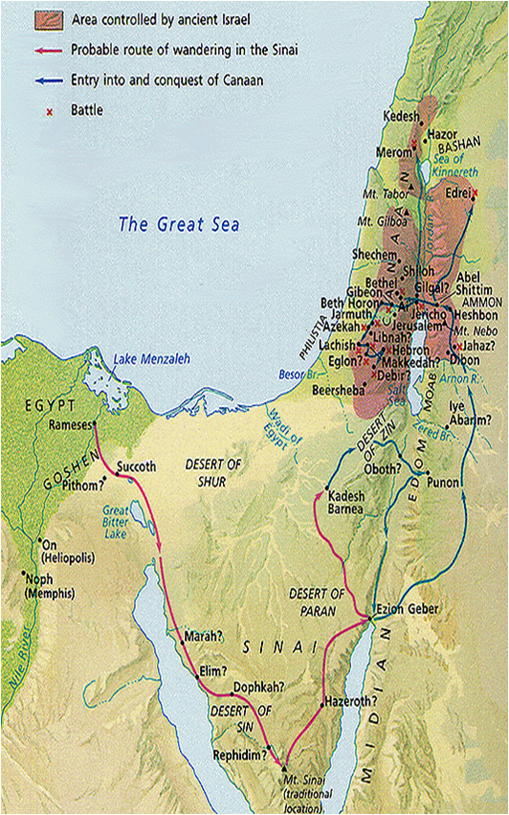
Genesis 45:10 – Jacob and the family settled in Goshen
Exodus 12:37 – Exodus from Rameses to Succoth
Numbers 13 – The 12 spies sent in from Kadesh
Numbers 33 – The Route through the wilderness
Deuteronomy 34 – The Death of Moses on Mount Nebo
Joshua 3 – Crossing the Jordan river
Joshua 5-6 – The Fall of Jericho

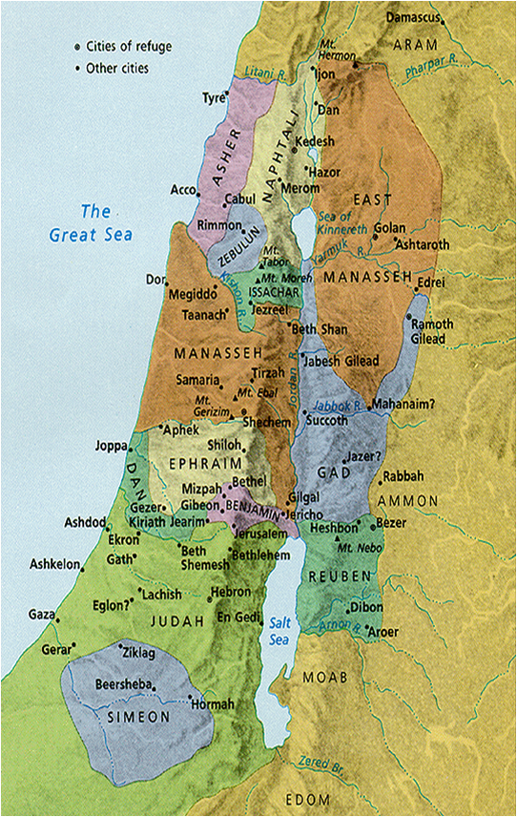
Numbers 32:33 (Joshua 13) – half the tribe of Manasseh, Gad and Reuben given land to the East of the Jordan
Joshua 14-19 – Land to the West of the Jordan allotted

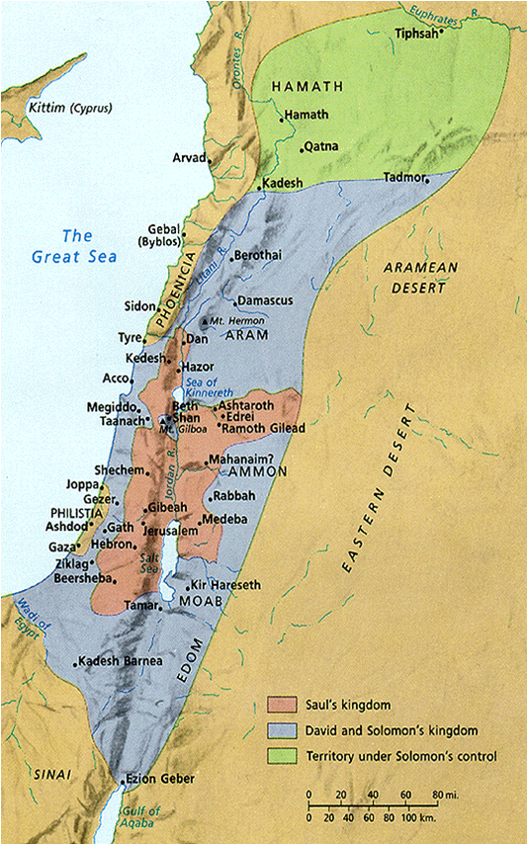
Battles with the Philistines (1 Samuel 13:4)
Defeated by David (2 Samuel 8:1)
David defeated the Moabites – 2 Samuel 8:2
2 Samuel 8:11-12 – David subdued the Edomites, Moabites, Ammonites, Philistines and Amalekites
Solomon’s rule extended even further than David – 2 Chronicles 9:26
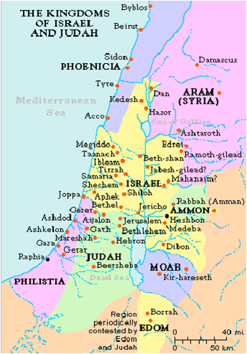

Battles with the Philistines (1 Samuel 13:4)
Defeated by David (2 Samuel 8:1)
David defeated the Moabites – 2 Samuel 8:2
2 Samuel 8:11-12 – David subdued the Edomites, Moabites, Ammonites, Philistines and Amalekites
Solomon’s rule extended even further than David – 2 Chronicles 9:26

